Database Schema and Instance

The overall design of the database is called database schema. Schema will not be changed frequently. It is the logical structure of a database. It does not show the data in the database.

The schema is pictorially represented as follows −

Types of Schema

The different types of schemas are as follows −

* **Physical schema** − It is a database design at the physical level.It is hidden below the logical schema and can be changed easily without affecting the application programs.
* **Logical schema** − It is a database design at the logical level. Programmers construct applications using logical schema.
* **External** − It is schema at view level. It is the highest level of a schema which defines the views for end users.

Generally the Database Management System (DBMS) assists one physical schema, one logical schema and several sub or external schemas.

Database schema refers to the format and layout of the database in which the data will be stored. It is the one thing that remains the same throughout unless otherwise modified. It defines the structure of what type of data and how it will be stored.

Example

A database schema for a person will have fields for name, email, phone and address as shown below −

**Person**

|  |  |  |
| --- | --- | --- |
| Name | Email | Phone no |

Instance

Instance or extension or database state is a collection of information that stored in a database at a particular moment is called an instance of the database. The Database instance refers to the information stored in the database at a given point of time. Thus, it is a dynamic value which keeps on changing.

Example

A database instance for the Person database can be (User1,emai.com,11345679,addr) So the person construct will contain their individual entities in the attributes called as instance. This is shown below −

**Person**

|  |  |  |
| --- | --- | --- |
| Name | Email | Phone no |
| BOB | kksd@yasd.com | 2343435 |
| JANU | werwr@sdas.in | 5345464 |
| PRIYA | wefrwer@sdf.com | 2342342 |

Differences

The major differences between schema and instance are as follows −

| **Database Schema** | **Database Instance** |
| --- | --- |
| It is the definition of the database or it is defined as the description of the database. | It is a snapshot of a database at a specific moment. |
| It rarely changes. | It changes frequently. |
| Example” We take two tables emp table and dept table.Emp   |  | | --- | | Id | | Name | | Salary | | dept |   Dept   |  | | --- | | Dept_id | | dname |   Emp and dept both called as schemas It gives database definition | At a moment, what is the value of the database schema is called instance.At t=8 A.M   | **Empid** | **name** | **salary** | **did** | | --- | --- | --- | --- | | 1 | A | 5000 | d1 | | 2 | B | 2000 | d2 |   At t=9 A.M   |  | | --- | | 3 | | C | | 3000 | | d3 |   Empid 1 and 2 are called as Instance 1 At time 9 A.M instance 2 changes |
| This corresponds to the variable declaration of a programming language. | The value of the variable in a program at a point in time corresponds to an instance of the database schema. |

Data Models

Data Model is the modeling of the data description, data semantics, and consistency constraints of the data. It provides the conceptual tools for describing the design of a database at each level of data abstraction. Therefore, there are following four data models used for understanding the structure of the database:

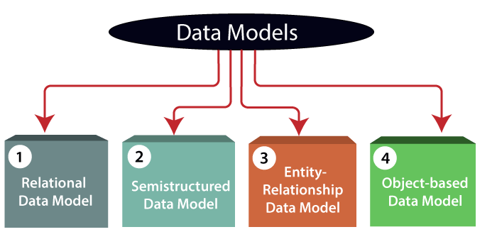

**1) Relational Data Model:** This type of model designs the data in the form of rows and columns within a table. Thus, a relational model uses tables for representing data and in-between relationships. Tables are also called relations. This model was initially described by Edgar F. Codd, in 1969. The relational data model is the widely used model which is primarily used by commercial data processing applications.

**2) Entity-Relationship Data Model:** An ER model is the logical representation of data as objects and relationships among them. These objects are known as entities, and relationship is an association among these entities. This model was designed by Peter Chen and published in 1976 papers. It was widely used in database designing. A set of attributes describe the entities. For example, student_name, student_id describes the 'student' entity. A set of the same type of entities is known as an 'Entity set', and the set of the same type of relationships is known as 'relationship set'.

**3) Object-based Data Model:** An extension of the ER model with notions of functions, encapsulation, and object identity, as well. This model supports a rich type system that includes structured and collection types. Thus, in 1980s, various database systems following the object-oriented approach were developed. Here, the objects are nothing but the data carrying its properties.

**4) Semistructured Data Model:** This type of data model is different from the other three data models (explained above). The semistructured data model allows the data specifications at places where the individual data items of the same type may have different attributes sets. The Extensible Markup Language, also known as XML, is widely used for representing the semistructured data. Although XML was initially designed for including the markup information to the text document, it gains importance because of its application in the exchange of data.